AMERICAN UNIVERSITY OF BEIRUT

END-TO-END ANALYTICS DEMAND FORECASTING AND INVENTORY OPTIMIZATION: URTH MAMA, A LEBANESE E-COMMERCE

by
RABAB ALI SWAIDAN

A Capstone Project
submitted in partial fulfillment of the requirements
for the degree of Master in Business Analytics
to the Suliman S. Olayan School of Business
at the American University of Beirut

Beirut, Lebanon
April 2026

AMERICAN UNIVERSITY OF BEIRUT

END-TO-END ANALYTICS DEMAND FORECASTING AND INVENTORY OPTIMIZATION: URTH MAMA, A LEBANESE E-COMMERCE

by
RABAB ALI SWAIDAN

Approved by:

Company Representative:

Full Name: | Batoul Swayden
Position: | Operations Manager
Company Name: | Urth Mama
Contact Information: | 03034960 - batoulurthmama@gmail.com
Signature:

ABSTRACT
OF THE PROJECT OF

Rabab Ali Swaidan for Master of Business Analytics

Title: End-To-End Analytics Demand Forecasting and Inventory Optimization: Urth Mama, a Lebanese E-Commerce

Demand forecasting and inventory management are critical challenges for small e-commerce businesses, where limited historical data, seasonal volatility, and external disruptions complicate planning decisions. This project presents an end-to-end analytics system developed for Urth Mama, a Lebanese e-commerce retailer specializing in reusable children's school accessories. Using 41 months of Shopify transaction data, the system integrates data cleaning, time-series forecasting, Pareto-based product classification, and inventory optimization into a single automated pipeline. A SARIMAX model with exogenous regressors for external disruptions and a business maturity structural break achieved a MAPE of 16.73% on a six-month holdout, outperforming the naïve benchmark by 38 percentage points. Product-level unit forecasts were generated using a tiered Exponential Smoothing approach matched to each product's data availability, covering 112 products across variant-level allocations. Safety stock and reorder point recommendations were computed at the variant level using ABC-adjusted service-level parameters. The system was deployed as an interactive Streamlit dashboard, enabling non-technical users to upload new sales data and regenerate all forecasts, classifications, and inventory recommendations automatically.

Contents
ABSTRACT 3
Introduction 7
Literature Review 9
Methodology 11
Data Source and Description 11
Data Cleaning and Preparation 11
Exogenous Events and Data Adjustments 12
Business-Level Forecasting Model 13
Prediction Intervals 14
Product-Level Forecasting 15
ABC Classification 16
Inventory Optimization 16
Dashboard and Pipeline Design 16
Results 18
Exploratory Findings 18
Business-Level Forecast 18
Machine Learning Attempts 20
Prediction Interval Performance 20
Product-Level Results 21
ABC Classification Results 22
Inventory Optimization Results 22
Dashboard Implementation 23
Discussion 25
Limitations 29
Recommendations 30
Conclusion 31
References 32
Appendix 34
Average Order Value: New vs Repeat Customers 37

Illustrations

- Monthly sales over time 18
- Forecasts distribution till June 2027 19
- Pareto Chart for products vs revenue generated 22
- Dashboard layout and sections 23
- Dashboard snapshot of average promotional activity influence 24
- New vs repeat customers distribution 24
- New customers distribution across months 24

Introduction
The rapid expansion of e-commerce, which was highly accelerated by the COVID-19 pandemic, has fundamentally transformed business models. According to McKinsey, a ten-year growth of U.S. e-commerce penetration was compressed into only three months during the pandemic period (Luo et al., 2023). As digital transactions increased in volume and complexity, data-driven decision-making has shifted from being a competitive advantage to an operational necessity. Among the most critical analytical capabilities in online retail is demand forecasting. Accurate forecasting enables firms to optimize inventory allocation, reduce stockouts and overstocking, improve cash flow management, and enhance customer satisfaction (Fildes et al., 2022). Conversely, poor forecasting practices lead to excess holding costs, lost sales, operational inefficiencies, and weakened strategic planning. In highly dynamic retail environments characterized by seasonality and promotional cycles, the need to adopt robust forecasting models has become inevitable.
This capstone project develops a comprehensive forecasting and analytics framework for an e-commerce business operating on a Shopify platform. The selected company, Urth Mama, is a digitally native retail brand specializing in reusable lunchboxes, water bottles, and related accessories targeted mainly at school-aged children. The company operates primarily through online channels and relies heavily on transaction-level data captured from its e-commerce system. While the business has accumulated substantial historical data on orders, products, and customer behavior, these data have not been systematically leveraged for advanced predictive analytics. Forecasting decisions have traditionally relied on descriptive insights and the established high/low seasonal trend.
The central problem addressed in this project is the absence of a structured, data-driven forecasting system that can support inventory planning and strategic decision-making. Specifically, while the company has preserved its data for the past four years, those data were not utilized in a pipeline that can feed current and future decisions. This gap limits their ability to proactively manage demand fluctuations, particularly during peak seasonal periods and promotional events. An equally important utility that has not been leveraged is the understanding of customer behavior, and targeting campaigns to attract new customers while retaining existing ones.
Existing approaches in retail forecasting range from naïve benchmarks and moving averages to more sophisticated statistical and machine learning techniques. Traditional time-series models such as Holt-Winters exponential smoothing and seasonal decomposition methods have been widely adopted due to their interpretability and strong performance in structured retail data (Hyndman & Athanasopoulos, 2021). The Holt-Winters method, which extends simple exponential smoothing to incorporate both trend and seasonality components, has proven particularly effective for retail demand patterns (Kumar et al., 2024). More recently, machine learning approaches, including gradient boosting models and neural networks, have been applied to capture nonlinear patterns and complex interactions (Mitra et al., 2022). However, these advanced techniques often require extensive feature engineering, large-scale data infrastructure, and computational resources that may not align with the operational scale of small-to-medium e-commerce businesses. Furthermore, highly complex models may reduce interpretability, which is critical for managerial decision-making.
The novelty of this project lies not in proposing an entirely new forecasting algorithm, but in designing a structured forecasting pipeline tailored to the operational realities of a growing e-commerce retailer. The adopted approach integrates data cleaning, aggregation, seasonal decomposition, and forecasting modeling into a cohesive framework. The process begins with transforming raw transactional Shopify exports into structured daily and monthly time-series datasets. This includes date parsing, handling missing values, aggregation at relevant temporal levels, and ensuring consistency in product-level performance metrics before deploying any forecasting models.
For inventory optimization, this project employs ABC analysis, a well-established categorization technique based on the Pareto Principle for determining which items should receive priority in inventory management (Ravinder & Misra, 2014). This classification approach divides inventory into three categories—A, B, and C—based on annual consumption value, enabling differentiated service-level policies and safety stock calculations (Pérez Vergara et al., 2020). Safety stock levels are computed using the standard formula incorporating demand variability and lead time, with service-level multipliers adjusted by product class.
The objectives of this capstone are therefore: first, to construct a reproducible data engineering pipeline that converts raw e-commerce data into modeling-ready time-series structures; second, to develop and validate a forecasting model capable of capturing seasonal retail patterns; third, to evaluate forecast reliability using statistical diagnostics and accuracy metrics; and finally, to translate model outputs into actionable business insights that can inform inventory planning, customer targeting, and revenue projections.
This project contributes at both methodological and practical levels. Methodologically, it demonstrates how classical time-series techniques can be systematically applied and validated within a real-world e-commerce context. Practically, it delivers an operational forecasting tool that can be integrated into Urth Mama's decision-making processes. This project bridges the gap between theoretical forecasting models and practical business implementation.

Literature Review
Data generation in e-commerce is a continuous process. From customer behavior, transactions, to product performance and characteristics. This process is fueled by online channels that produce high-volume data which can be leveraged to optimize supply chain processes, pricing and marketing strategies, in addition to customer understanding (Laudon & Traver, 2023). The challenge that comes with the e-commerce data, however, is its dynamic nature, that is influenced by several factors, mainly seasonality, promotions, and platform performance. This makes accurate forecasting critical and necessitates cautious interpretation and recommendations.
Having established the challenging task of forecasting for e-commerce, it is important to highlight why it’ worth it. Data-driven decision making in e-commerce has been shown to significantly improve firm productivity and profitability. Brynjolfsson, Hitt, and Kim (2011) demonstrate that organizations adopting analytics-driven practices outperform competitors in output and efficiency, highlighting the strategic importance of predictive analytics in digital commerce environments. In addition, empirical studies show that effective forecasting improves inventory turnover, reduces waste, and enhances supply chain resilience (Choi, Wallace, & Wang, 2018). Forecasting is also essential for capacity planning, employee recruitment, and cash-flow management, particularly for small and medium-sized online retailers operating under tight margins. Conversely, the absence of or inaccurate forecasts lead to overstocking, stockouts, lost sales, and increased holding costs, all of which directly affect customer satisfaction and financial performance of businesses (Hyndman & Athanasopoulos, 2021). In e-commerce, fulfillment speed and product availability are key competitive advantages, which further exemplifies the importance of accurate forecasts.
Several models were developed and tested for forecasting in a sales-business context. Classical time-series models remain widely used in retail due to their interpretability and robustness. Models such as ARIMA (AutoRegressive Integrated Moving Average), SARIMA (Seasonal AutoRegressive Integrated Moving Average), and Exponential Smoothing capture trend and seasonality patterns effectively when demand follows relatively stable historical structures (Box et al., 2015). Holt-Winters exponential smoothing, in particular, is commonly applied to product-level sales data with clear seasonal behavior.
While these models perform well for aggregated or stable demand, there are limitations that emerge in highly volatile e-commerce contexts, especially at the Stock Keeping Units (SKU) level where intermittent demand, promotions, and product lifecycle effects are present (Hyndman et al., 2008). Recent literature highlights a shift toward machine learning and hybrid forecasting models in e-commerce applications. Tree-based models, gradient boosting, and neural networks are increasingly adopted due to their ability to model nonlinear relationships and incorporate multiple explanatory variables such as price, promotions, and calendar effects (Makridakis et al., 2018). Deep learning architectures, including LSTM (Long Short-Term Memory) and temporal convolutional networks, have shown strong performance for complex demand patterns, particularly in large-scale retail platforms (Bandara, Bergmeir, & Smyl, 2020). However, these methods require substantial data, careful tuning, which often affects interpretability that remains the main goal in business settings where explainability is essential for decision support. As a result, many practitioners adopt hybrid approaches, combining classical time-series models with machine learning or using statistical models as benchmarks for more complex methods (Makridakis et al., 2022).
Despite methodological advances, forecasting performance remains highly context-dependent. Most researches emphasize the importance of data preprocessing, aggregation level, seasonality detection, and residual diagnostics in achieving reliable forecasts (Hyndman & Athanasopoulos, 2021). Many studies focus on large-scale retailers, leaving smaller e-commerce businesses underrepresented.
In this capstone project, we address the abovementioned challenges by building a tailored forecasting model to Urth Mama’s transactional data, emphasizing data cleaning, product-level aggregation, seasonality analysis, and model diagnostics. By grounding the analysis in interpretable and widely adopted models, the project aims to provide actionable insights to the business owner, backed up with sound modeling that is tailored to the nature of data on hand.

Methodology

Data Source and Description
The dataset was obtained directly from the Shopify e-commerce platform, which hosts Urth Mama, a Lebanese online retailer. The raw export contained 22,547 line-item records spanning August 10, 2022 to December 19, 2025, representing 41 months of transactional activity. Each record corresponds to a single product line within an order and includes fields for order identification, customer name, product title and variant, date, pricing, discount details, and geographic information. The data encompasses all revenue-generating transactions processed through the Shopify storefront.

Data Cleaning and Preparation
The raw Shopify export required several preprocessing steps before it could be used for time-series modeling. Column names were standardized to lowercase with underscores. Date fields were parsed to datetime format, and numeric columns including sales, discount, and quantity fields were coerced from string representations. Shipping-only rows, identified by missing product titles and zero order quantities, were separated from product rows to prevent inflating revenue figures with shipping charges.
Order-level aggregation was performed by grouping line items by order name, summing quantities and revenue fields, and merging shipping fees and discount information back to the order level. Duplicate order entries were collapsed through a second aggregation pass. The resulting orders dataset contained one row per unique order with fields for total sales, gross sales, net sales, shipping fees, discount values, and item counts.
A product-monthly performance table was constructed by aggregating line-item data at the product-variant-month level, capturing units sold, net revenue, and order counts for each product in each month. This table served as the foundation for product-level forecasting, ABC classification, and inventory optimization.

Exogenous Events and Data Adjustments
Two categories of exogenous disruptions were identified in the data. First, the initial months of business operations (August through October 2022) exhibited revenue patterns consistent with a launch phase rather than steady-state demand. A binary maturity indicator was constructed, taking a value of zero before July 2023 and one thereafter, to allow the forecasting model to distinguish between the ramp-up period and the mature operating phase.
Second, the escalation of the War in Lebanon during late 2024 severely disrupted business operations. October and November 2024 recorded revenue of $1,614 and $3,473 respectively, far below the seasonal norms for those months. Rather than allowing these observations to distort the seasonal pattern, a two-pronged approach was employed. For mid-series war months (October and November 2024), the observed revenue values were first replaced with the average revenue from the same calendar month in non-war years, preserving the continuity and seasonal integrity of the time series. Dummy variables for these months were then included as exogenous regressors in the SARIMAX model to capture the residual shock effect. For trailing war months appearing at the end of the data series (March 2026), the affected observations were dropped entirely, and the forecast horizon was adjusted to begin from the first month following the last clean observation. By replacing mid-series anomalies to protect seasonal estimation while retaining dummy variables to quantify the disruption, we ensured that neither the seasonal pattern nor the model’s ability to measure the war’s impact was compromised. A similar imputation was applied to January 2025, which was inflated by a delayed shipment that arrived in late December 2024 but was recorded as January revenue. The observed value was replaced with the average of January 2023 and January 2024, adjusted by a growth factor derived from the ratio of recent to earlier twelve-month averages, preserving the underlying growth trend while removing the one-off anomaly.

Business-Level Forecasting Model
The business-level monthly revenue series was constructed by aggregating order-level product revenue (total sales minus shipping fees) to the month level and setting a monthly start frequency. Shipping fees, which averaged approximately $4 per order and totaled $20,126 across the dataset (4.8% of gross revenue), were excluded to ensure the forecast reflects product demand rather than logistics costs. Prior to aggregation, wholesale customers were identified and excluded from the forecasting dataset. Seven wholesale accounts were identified based on customer naming patterns and order characteristics: these accounts placed large, sporadic bulk orders that did not follow seasonal retail patterns. Across the 41-month dataset, these wholesale transactions comprised 43 orders totaling approximately $58,000, representing roughly 14% of total revenue. Including these transactions in the time series distorted the seasonal pattern and inflated forecast values for months that happened to contain wholesale orders, particularly January 2025 which contained $5,400 in wholesale revenue (46% of that month’s total). By excluding wholesale transactions from the forecasting model, the SARIMAX specification could focus on the predictable retail demand pattern. Wholesale revenue was instead handled separately: the historical monthly average ($1,425) was computed and reported as an expected wholesale allowance over the forecast horizon, with a note that the timing of individual wholesale orders cannot be predicted. This approach preserves the full revenue picture while ensuring the forecasting model captures only the predictable component of demand. The filtered series was then used to fit a Seasonal Autoregressive Integrated Moving Average with eXogenous regressors (SARIMAX) model. Six candidate model specifications were evaluated, varying the non-seasonal ARIMA order (p,d,q) and the seasonal order (P,D,Q,s) with s fixed at 12 to capture the annual seasonal cycle.
The candidate models included SARIMAX(1,1,1)(0,1,1,12), SARIMAX(0,1,1)(1,0,1,12), SARIMAX(1,1,1)(1,0,1,12), SARIMAX(1,1,0)(1,0,1,12), SARIMAX(1,0,1)(1,0,1,12), and SARIMAX(2,1,1)(1,0,1,12). Model selection was performed using the Akaike Information Criterion (AIC), with the lowest AIC model retained for forecasting. All models included three exogenous regressors: dummy variables for the October 2024 and November 2024 war months, and the maturity indicator.
Model validation was conducted using a rolling origin approach with a six-month holdout test set. Forecast accuracy was assessed using Mean Absolute Error (MAE), Root Mean Squared Error (RMSE), Mean Absolute Percentage Error (MAPE), and Mean Absolute Scaled Error (MASE). The MASE was computed relative to a naive seasonal benchmark to evaluate whether the model provided improvement over a simple last-value forecast.
To evaluate whether machine learning could outperform the classical SARIMAX approach, five models were tested using features engineered from the Urth Mama sales dataset. The feature set comprised 20 variables derived entirely from the available Shopify transaction data: the calendar month (1–12), quarter, and year of each observation; cyclical sine and cosine transformations of the month to capture the circular nature of seasonality (so that December and January are treated as adjacent); lagged revenue at 1, 2, 3, 6, and 12 months (e.g., for predicting July 2025, the model received June 2025's revenue as lag-1 and July 2024's revenue as lag-12); rolling averages over 3, 6, and 12-month windows and the 3-month rolling standard deviation to capture recent demand momentum and volatility; year-over-year revenue change; the same exogenous regressors used in SARIMAX (war dummies for October and November 2024, maturity indicator switching on at July 2023); a binary peak-season flag for July through September; and a linear trend proxy (months since the start of the series). After feature engineering, the lag and rolling calculations consumed the first 12 months, leaving only 23 usable training observations — a ratio of roughly one observation per feature — against a 6-month test set (July–December 2025). Linear Regression, Ridge Regression (L2 regularization, alpha = 10), Random Forest (100 trees, max depth 4), Gradient Boosting (100 estimators, max depth 3, learning rate 0.1), and XGBoost (100 estimators, max depth 3, learning rate 0.1) were each fitted on the training set and evaluated on the same test period used for SARIMAX.

Prediction Intervals
Prediction intervals were constructed using the out-of-sample forecast errors from the validation period. For each calendar month present in the test set, the absolute percentage error was computed and used as the spread parameter for that month. For calendar months not represented in the test set, the overall MAPE was applied as a conservative default. The 95% prediction interval was computed as the point forecast plus or minus the spread parameter multiplied by the forecast value, with a floor constraint ensuring lower bounds did not fall below 15% of the point forecast. The 80% interval was computed as 65% of the 95% interval width, consistent with the ratio of the corresponding z-scores (1.28/1.96).

Product-Level Forecasting
Product-level demand forecasts were generated for all products meeting minimum activity thresholds of six active months and three months with non-zero sales. Before fitting any models, each product’s monthly unit series was zero-filled from its first recorded sale month through the end of the dataset. Without this step, ETS would treat non-consecutive sales months as consecutive observations, distorting trend and seasonal estimates.
Products with very low average demand (below one unit per month) were assigned forecasts based on their trimmed recent mean, as formal time-series models offer no advantage for such sparse series. For products with at least 24 months of history, a full seasonal Exponential Smoothing (ETS) model was fitted with additive seasonality and a period of 12, iterating through combinations of additive and no-trend components with damped and undamped variants. Products with 13 to 23 months of data, which is sufficient for one but not two complete seasonal cycles, received a seasonal-index decomposition, which consists of a non-seasonal ETS used to estimate the demand level, and a monthly seasonal index derived from the available cycle was applied to project seasonally adjusted forecasts. Products with fewer than 13 months were fitted with non-seasonal ETS or, if fitting failed, assigned flat forecasts at their historical mean.
Variant-level allocation was performed by computing the sales mix share of each product variant over the most recent six months and applying these proportions to the product-level forecasts. This approach assumes that the recent variant mix is representative of near-term demand composition.
Product-level forecast accuracy was evaluated using a seasonal holdout approach. The holdout window was set to the July through September period of the most recent complete peak season in the data, as this represents the operationally critical back-to-school demand surge. Training data consisted of all observations strictly prior to the holdout window. Only products that were active during the holdout months, had at least six months of training history, and averaged at least one unit per month were included in the evaluation, as MAPE is structurally unreliable when actual values approach zero. For each qualifying product, the tiered forecasting procedure was applied to the training subset and the resulting three-month forecast was compared against actual demand using MAE, MAPE, and MASE.

ABC Classification
Products were classified into three tiers using a standard Pareto analysis based on cumulative revenue contribution. Products were ranked by total historical revenue in descending order, and cumulative revenue percentages were computed. Class A was assigned to products accounting for the first 80% of cumulative revenue, Class B to those in the 80% to 95% range, and Class C to the remainder. This classification informed differentiated inventory policies, with higher service levels applied to Class A products.

Inventory Optimization
Safety stock and reorder point calculations were based on standard inventory management formulas. Monthly demand statistics (mean and standard deviation) were computed for each product, and daily equivalents were derived by dividing monthly figures by 30. Safety stock was calculated as the product of a z-score corresponding to the target service level (z = 1.65 for 95% service), the standard deviation of daily demand, and the square root of the lead time in days (assumed at 14 days). Reorder points were computed as the sum of average daily demand multiplied by lead time plus the safety stock.
Class-specific adjustments were applied to safety stock: Class A products received a 20% buffer increase to minimize stockout risk for high-revenue items, Class B products retained the baseline calculation, and Class C products received a 20% reduction to limit capital tied up in slow-moving inventory. Recommended monthly stock levels were computed as average monthly demand plus the adjusted safety stock.

Dashboard and Pipeline Design
The analytics system was implemented as a Streamlit web application with an integrated data processing pipeline. The pipeline accepts raw Shopify CSV exports and executes the full sequence of data cleaning, business-level forecasting, product-level forecasting, ABC classification, and inventory optimization in a single automated run. Output files are written in CSV format and consumed directly by the dashboard interface. The dashboard comprises eight navigable pages: a Data Refresh page for uploading new exports and triggering pipeline re-execution; a Business Overview with key performance indicators and monthly revenue trends; a Product Classification page presenting the ABC/Pareto analysis; a Sales Forecast page displaying the 18-month business-level projection with prediction intervals; a Product Explorer allowing drill-down into individual product forecasts, variant breakdowns, and inventory parameters; an Inventory page with safety stock and reorder point recommendations; a Promotions page analyzing discount activity, promotional categories, and revenue lift; and a Customers page examining retention rates, order frequency distributions, and customer lifetime value.
A data refresh mechanism was incorporated to ensure the tool remains operational beyond the initial analysis period. The business owner can upload a new Shopify export through the dashboard interface, triggering a complete pipeline re-execution. All dashboard pages, including sales forecasts, product forecasts, product classifications, and inventory recommendations, are updated to reflect the new data, based on an ETL (Extract-Transform-Load) pattern implemented in pipeline.py. Column mapping logic was implemented to accommodate differences between historical and current Shopify export formats.

Results

Exploratory Findings
The monthly revenue series revealed a strongly seasonal pattern dominated by the back-to-school period. August and September consistently generated the highest revenue, with averages of $27,000 and $30,300 respectively across 2023 to 2025, compared to an overall monthly average of approximately $9,800. The remaining months exhibited lower and more variable revenue, with March and December typically recording the weakest performance. Figure 1 illustrates monthly sales over time.
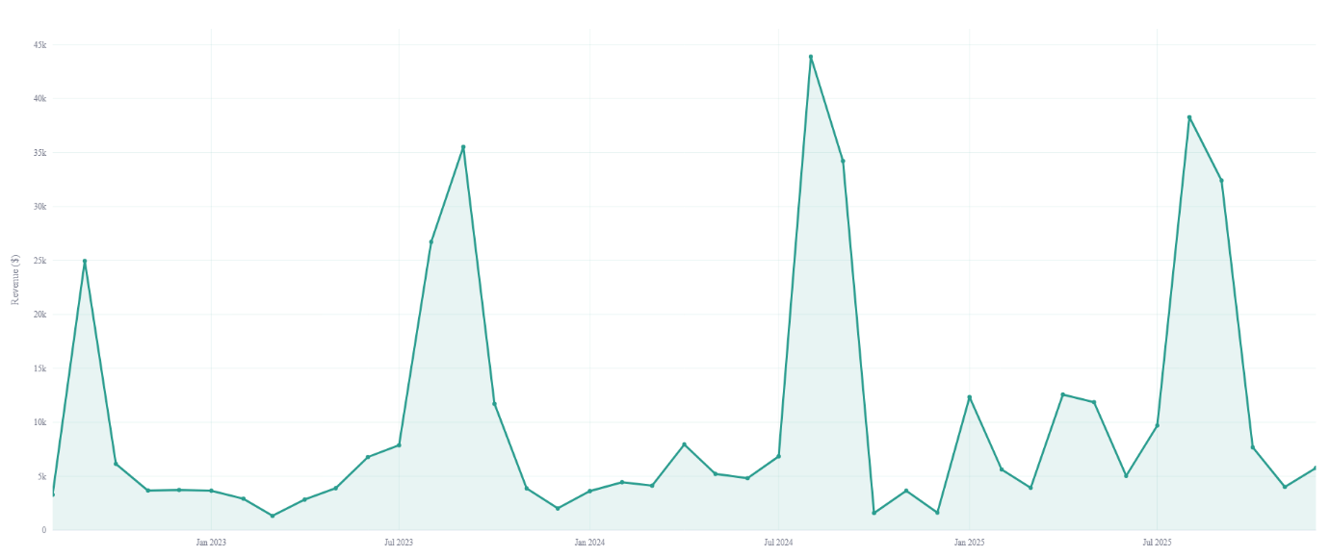
Figure 1 - Monthly sales over time
Year-over-year growth was evident across most months. Comparing 2023 to 2025, several months showed substantial increases: January grew from $3,499 to $11,885, April from $2,719 to $11,688, and May from $3,765 to $11,307. This growth pattern, concentrated in the non-peak months, suggests the business has been successfully expanding its customer base beyond the seasonal core.

Business-Level Forecast
The SARIMAX(1,1,1)(0,1,1,12) specification was selected as the best-performing model with the lowest AIC of 156.48, substantially below the next candidate at 385.11. On the six-month holdout test set (July to December 2025), the model achieved a MAPE of 16.73%, RMSE of $1,405, and MASE of 0.231. The MASE well below 1.0 confirms that the model substantially outperforms the naive benchmark, which recorded a MAPE of 55.12%. The exclusion of wholesale transactions from the forecasting dataset was critical to achieving this accuracy: when wholesale orders were included, the model MAPE was 29%, as the sporadic wholesale purchases created noise that the seasonal model could not capture. Forecasts till mid-2027 are shown in Figure 2.
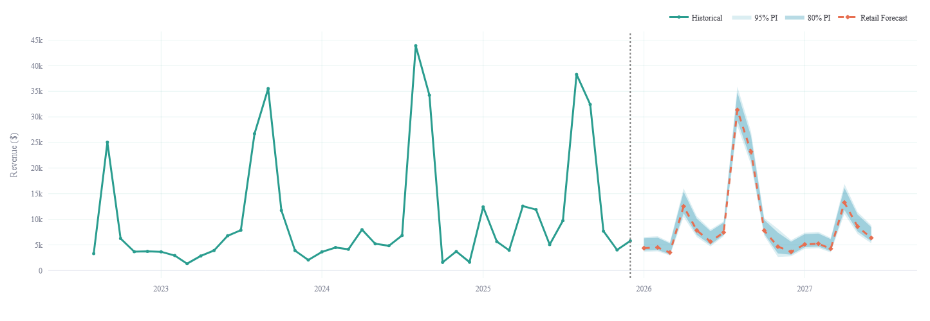
Figure 2 - Forecasts distribution till June 2027
The war month dummy variables captured the conflict-related disruption. The maturity regressor reflected the structural shift between the launch phase and the established operating period. The 18-month retail forecast projected total revenue of approximately $159,000, with monthly averages ranging from approximately $3,500 in low-demand months to over $31,000 during the August peak. In addition, a wholesale revenue allowance of approximately $26,000 was calculated based on the historical monthly average of $1,425, bringing the combined 18-month projection to approximately $185,000. The wholesale component is reported as a lump-sum expectation rather than assigned to specific months, reflecting the unpredictable timing of bulk B2B orders.
Residual diagnostics were conducted on the fitted SARIMAX(1,1,1)(0,1,1,12) model to verify that no systematic patterns remained unexplained. The Ljung-Box test confirmed that residuals are white noise at both lag 6 (p = 0.96) and lag 12 (p = 0.33), indicating that the model successfully captured the trend, seasonality, and autocorrelation structure in the data. The residual autocorrelation function showed values near zero at all lags except a minor spike at lag 11 (0.42), which was not statistically significant in the Ljung-Box framework. Normality tests (Jarque-Bera p < 0.001, Shapiro-Wilk p < 0.001) rejected the assumption of normally distributed residuals, with the distribution exhibiting right skewness (1.17) and excess kurtosis (5.57). Residual variance was also higher in the first half of the series (launch period) than the second half (mature period), reflecting the structural shift captured by the maturity regressor. While the white noise result validates the model's ability to extract all learnable signal from the data, the departures from normality and constant variance reinforce the decision to construct prediction intervals from empirical out-of-sample errors rather than the model's parametric variance estimates, which assume both properties hold.

Machine Learning Attempts
To validate the choice of SARIMAX over machine learning approaches, five ML models were tested using the same train/test split and data preparation. Features included calendar encodings, lagged revenue (1, 2, 3, 6, and 12 months), rolling statistics (3, 6, and 12-month means), year-over-year change, and the same exogenous regressors used in SARIMAX (war dummies, maturity). With only 23 usable training observations and 20 features, all ML models underperformed. Linear and Ridge regression overfit the training data completely (0% training error, unreliable on new data). The best ML result was Gradient Boosting at 29.8% MAPE, which was nearly double SARIMAX's 16.7%. XGBoost (43.8%) and Random Forest (44.6%) performed similarly to the naive benchmark. Feature importance analysis revealed that XGBoost relied primarily on seasonal encoding (48%) and a peak-season flag (30%), essentially attempting to manually reconstruct the seasonal structure that SARIMAX captures natively through seasonal differencing. These results confirm that classical time-series methods remain superior for individual short series, consistent with findings from the M4 and M5 forecasting competitions.

Prediction Interval Performance
Prediction intervals varied in width according to each month’s historical forecast accuracy. Months in the test set (July through December) received intervals calibrated to their actual test errors: July through October received the tightest intervals at approximately ±10–13%, December at ±24%, and November the widest at ±44%. Months without direct test-set observations (January through June) carried intervals of approximately ±17%, based on the overall MAPE applied as a conservative default." Table 1 represents predictions for the year 2026, with their respective intervals.
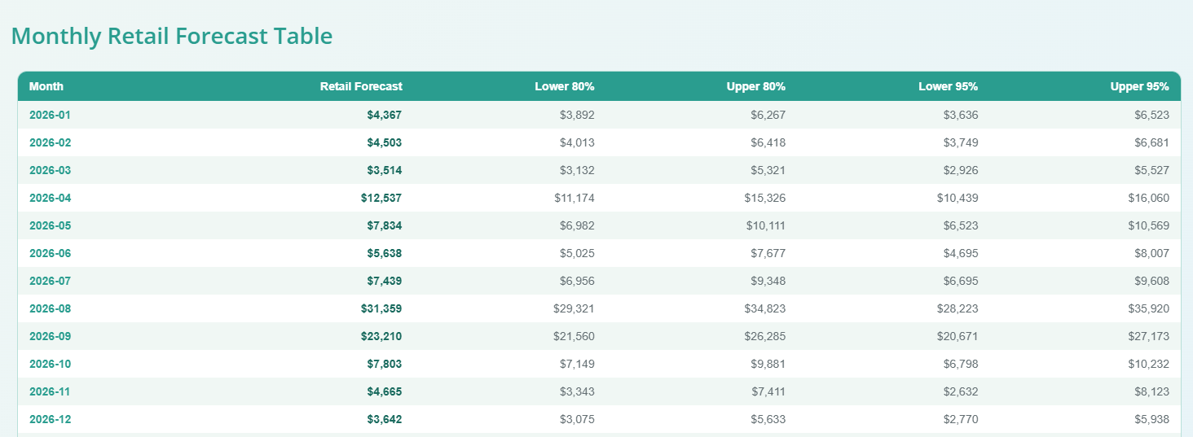
Table 1 - Point forecasts for 2026 with their prediction intervals

Product-Level Results
Of 169 unique products in the dataset, 112 met the minimum history requirements for forecasting. These products were fitted individually using the tiered ETS strategy, and 12-month unit forecasts were generated for each. Products with 24 or more months of history received full seasonal ETS models, those with 13 to 23 months received seasonal-index decomposition forecasts, and shorter-history products received non-seasonal ETS or mean-based projections. The top product by forecast volume was the OmiePod fork and spoon set (Class A), with a projected 606 units over the forecast horizon. Variant allocation distributed product-level forecasts across size, color, and configuration variants based on the most recent six months of sales composition. Table 2 shows several Class A products and their demands.
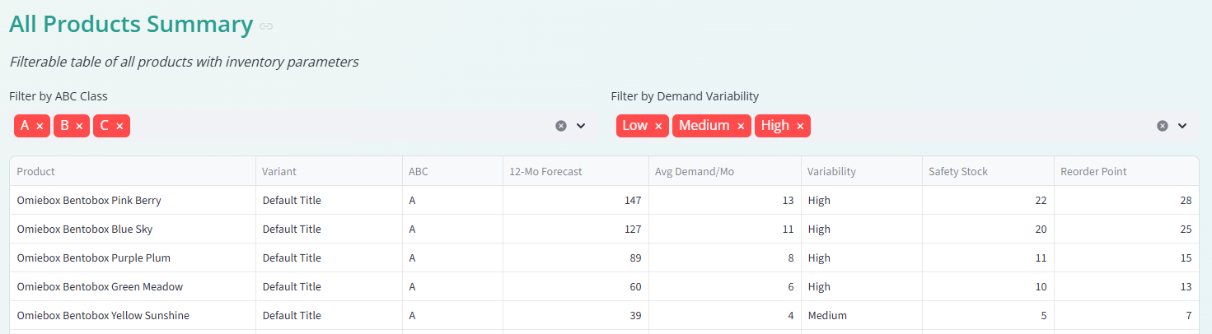
Table 2- Product-level forecasts for some Class A products

The seasonal holdout evaluation, conducted over the July through September peak window, assessed forecast quality for products meeting the evaluation criteria. Products that were inactive during the peak, had insufficient training history, or averaged below one unit per month were excluded, as MAPE is unreliable for near-zero actuals. Among the evaluated products, the median MAPE and median MASE provided summary measures of forecast accuracy across the product catalog, with the majority of products falling within acceptable error ranges for inventory planning purposes.

ABC Classification Results
The Pareto analysis (Figure 3) identified 26 products as Class A, accounting for 80% of total revenue. An additional 38 products were classified as Class B (contributing the next 15%), and 105 products fell into Class C (the remaining 5%). This distribution is consistent with the typical concentration observed in retail environments, where a small fraction of products drives the majority of revenue.
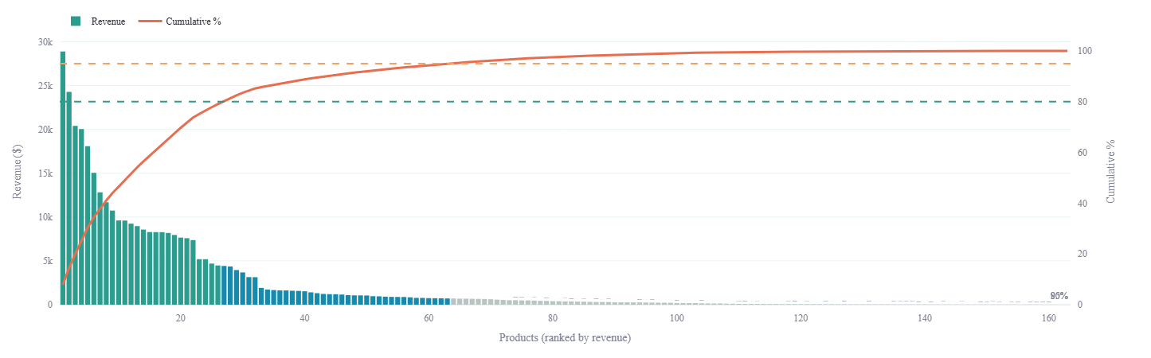
Figure 3 - Pareto Chart for products vs revenue generated

Inventory Optimization Results
Safety stock and reorder point recommendations were computed for all 169 products. Total recommended safety stock across the product catalog was 544 units. Class A products received elevated safety stock allocations reflecting their revenue importance and the 20% buffer multiplier. Demand variability analysis revealed a mix of low, medium, and high variability products, with high-variability items flagged for more frequent monitoring.

Dashboard Implementation
As outlined in the methodology section, the dashboard implemented EDA, business and product level forecasts, in addition to sections for promotional and customer behavior analysis. Figure 4 displays the dashboard layout and sections, and all outputs from the dashboard are added into Appendix A.
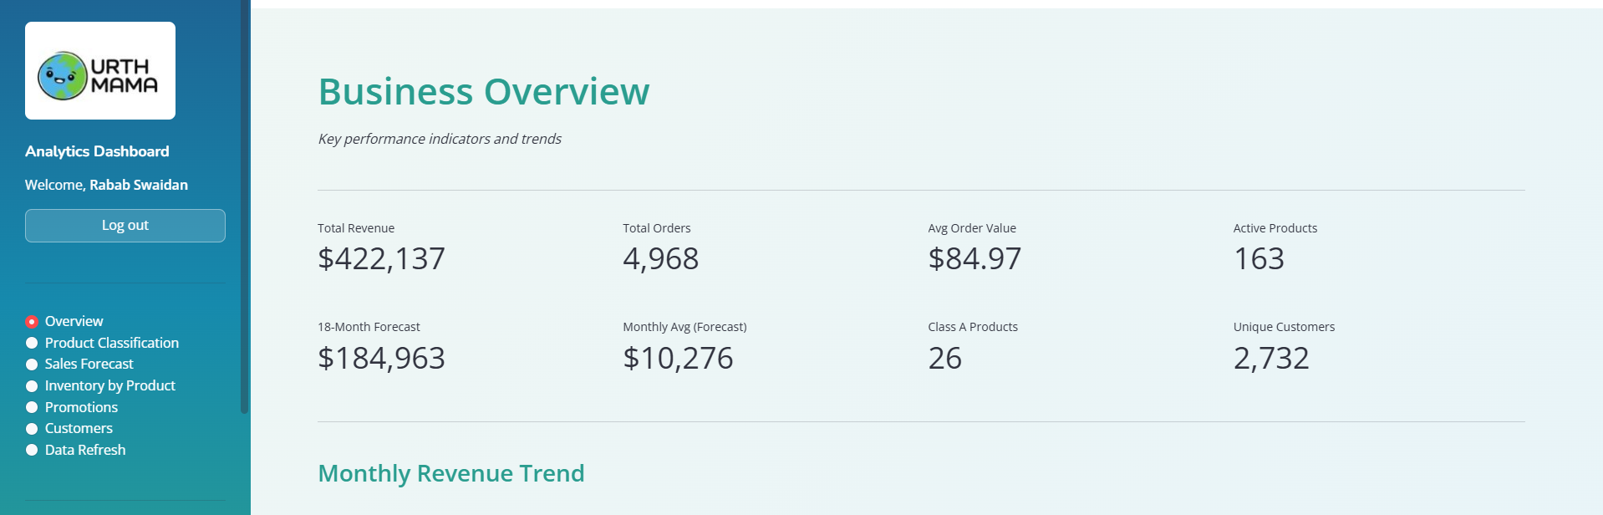
Figure 4 - Dashboard layout and sections
Previous sections detailed the business and product level forecasts, in addition to product classification. The dashboard presents additional data on two influential business components: customers and promotions. Of the 4,968 orders in the dataset, 622 (12.5%) included a discount, with total discounts given of $22,926. The largest discount category was gifts and freebies (306 orders, $11,682), followed by warranty and exchange adjustments (144 orders, $6,446) and operational discounts (69 orders, $1,479). Marketing-driven promotions including sales, influencer collaborations, and social media campaigns accounted for 53 orders and $659 in discounts. Days with active promotions averaged $574 in daily revenue compared to $223 on non-promotional days, a lift of 158%, with average order value $26 higher on promotional days ($85 versus $59), as shown in Figure 5. However, this comparison is observational, as promotional periods frequently overlap with peak seasonal demand, making it difficult to attribute the lift entirely to discounting activity.

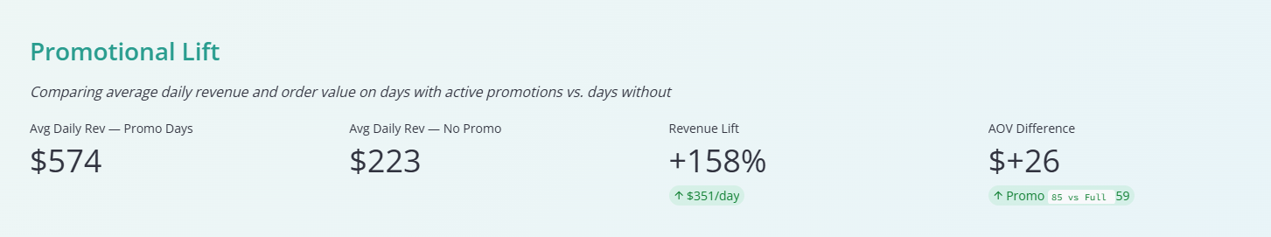
Figure 5 - Dashboard snapshot of average promotional activity influence
As for customer behavior analysis, the dataset contained 2,732 unique customers, of whom 1,693 (62%) made only a single purchase. The remaining 1,039 customers (38%) were repeat buyers, averaging 1.8 orders per customer overall (Figure 6). Repeat customers exhibited a higher average order value of $88 compared to $79 for one-time buyers. Average customer lifetime value was $155. The top 20% of customers contributed 58% of total revenue, indicating moderate revenue concentration. New customer acquisition averaged 67 customers per month, with the peak occurring in September 2023 at 279 new customers, coinciding with the back-to-school season. Figure 7 illustrates the distribution of new customers across months. The high one-time buyer rate suggests that customer retention represents a meaningful growth opportunity for the business.

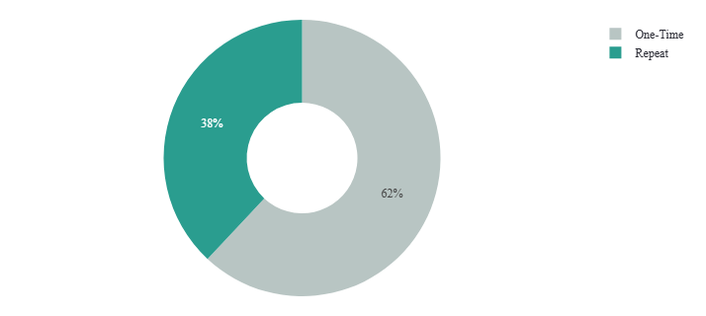
Figure 6 - New vs repeat customers distribution
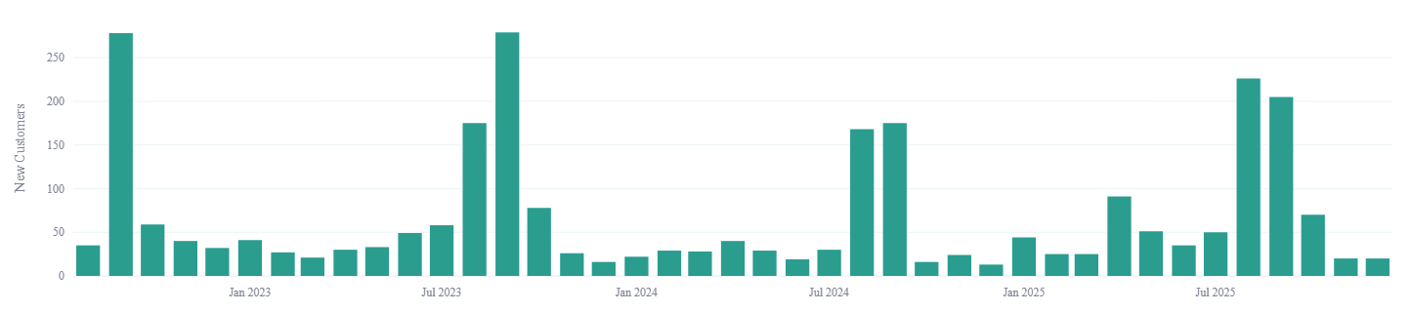
Figure 7 - New customers distribution across months

Discussion
The results demonstrate that a classical time-series approach, when combined with domain-informed adjustments, can deliver strong forecasting performance for a small e-commerce business. The SARIMAX model’s ability to capture the strong August-September seasonality while accommodating exogenous disruptions through dummy variables proved effective. The 16.73% MAPE on the retail forecast represents excellent performance by retail forecasting standards and a substantial improvement over the naive benchmark. This accuracy was achieved through two key methodological decisions: first, incorporating war-period disruptions and business maturity as explicit regressors; and second, excluding wholesale transactions to isolate the predictable seasonal retail demand from sporadic B2B orders.
The decision to use SARIMAX over the initially considered ETS approach was validated by the model comparison exercise. The original ETS model produced a test MAPE of 119.75% and a MASE of 2.828, performing substantially worse than the naive benchmark. This poor performance was attributable to the ETS model’s inability to account for the war-related disruptions and the structural break between the launch and mature phases of the business. By incorporating these effects as explicit regressors, SARIMAX achieved a MASE below 1.0. The additional decision to exclude wholesale transactions further improved accuracy from a MAPE of 29% to 16.73%, demonstrating that isolating predictable retail demand from sporadic wholesale orders is essential for accurate seasonal forecasting.
The prediction interval methodology evolved through several iterations during the project. Initial attempts using the SARIMAX model’s native parametric intervals produced unreasonably wide bands, with many lower bounds at or below zero, due to the instability of parametric variance estimation with seasonal differencing on a short series. Empirical interval methods based on per-month coefficients of variation were also tested but suffered from conflating year-over-year growth with demand volatility, since each calendar month had only three to four historical observations. The final approach, using out-of-sample MAPE as a proportional spread, produced intervals that were both statistically grounded and operationally meaningful.
The treatment of war-affected months also evolved during development. An initial approach that relied solely on dummy variables left the anomalous revenue figures in the time series, which distorted the seasonal decomposition within SARIMAX. The adopted solution—replacing mid-series war months with same-month averages from non-war years before fitting, while retaining the dummy variables as regressors—proved more effective. The replacement preserves the continuity of the seasonal pattern for estimation purposes, while the dummies still allow the model to quantify the magnitude of the disruption. For trailing war months at the end of the series, dropping the observations entirely was preferable to replacement, as the model would otherwise extrapolate from an artificially constructed final observation. This dual-treatment approach reflects a broader lesson: when external shocks are non-recurring and their mechanism is understood, encoding domain knowledge directly into the data preparation step can be more effective than relying on the model to learn the adjustment from limited examples.
The product-level tiered ETS approach represents a pragmatic response to the heterogeneous data availability across a product catalog. Rather than applying a single model specification to all products regardless of their history length, the tiered strategy matches model complexity to data richness. Products with two or more complete seasonal cycles receive full seasonal ETS, which can capture repeating annual patterns. Products with only one cycle receive a hybrid seasonal-index decomposition that extracts what seasonal signal exists without requiring the two-cycle minimum that formal seasonal ETS demands. Short-history and sparse products receive simpler treatments that avoid overfitting. The seasonal holdout evaluation confirmed that this adaptive strategy produces reasonable forecasts across the catalog, though individual product forecasts naturally carry greater uncertainty than the aggregated business-level model due to the sparsity and intermittency of individual product demand. The variant allocation step, while practical, assumes stationarity in the variant mix, which may not hold if the business introduces new colors or sizes.
The integrated dashboard and pipeline design addresses a practical gap that is often overlooked in academic forecasting studies. Many forecasting projects produce a one-time analysis that becomes outdated as soon as new data arrives. By embedding the forecasting logic into a reusable pipeline with a user-facing interface, this project ensures that the analytical outputs remain current and actionable. The dashboard scope expanded during development beyond its initial forecasting focus to include promotions analysis and customer behavior pages. The promotions analysis revealed that discount activity is concentrated in marketing-driven campaigns, with promotional days generating meaningfully higher average daily revenue than non-promotional days. However, this lift is observational rather than causal, as promotional periods often coincide with peak seasonal demand, making it difficult to isolate the true incremental effect of discounts. The breakdown by discount purpose (marketing, operational, gifts, and warranty) provides the business owner with visibility into where discount dollars are going, enabling more deliberate allocation of promotional budgets. The top promotional events analysis highlights which specific campaigns generated the most revenue, offering a basis for deciding which promotions to repeat and which to retire.
The customer behavior analysis identified a high proportion of one-time buyers relative to repeat customers, suggesting that customer retention represents a significant growth opportunity. Repeat customers exhibited higher average order values than first-time buyers, reinforcing the economic case for investing in retention strategies such as post-purchase follow-up campaigns or loyalty incentives. The monthly new customer acquisition trend provides a leading indicator of business growth, while the customer lifetime value ranking identifies the most valuable individual accounts. Together, these metrics move the dashboard beyond demand forecasting into a broader operational intelligence tool that supports marketing, retention, and customer relationship decisions alongside inventory planning.
Finally, the data refresh mechanism was tested with a new Shopify export extending through March 2026, confirming that the pipeline correctly processes new data, drops war-affected trailing months, retrains all models, and updates all dashboard components. This provides business owners with autonomous control over the dashboard. However, model should always be revised for future external regressors, especially in economically and politically volatile environment like Lebanon’s.
The SARIMAX model's MAPE of 16.73% positions this project favorably within the broader retail and e-commerce forecasting literature. Industry benchmarks indicate that traditional statistical methods typically achieve 15–40% MAPE for sales forecasting, while advanced machine learning systems with access to large datasets and rich feature sets reach 5–15% (Makridakis et al., 2022). The Urth Mama model falls at the strong end of the traditional range despite operating under significant constraints: only 41 monthly observations, no external predictive features such as marketing spend or web traffic, and non-recurring exogenous disruptions.
In a comparable retail context, de Castro Moraes et al. (2024) applied SARIMAX to multivariate retail sales data and reported a MAPE of 27.94% at the one-month horizon and 24.27% at the one-year horizon, with hybrid CNN-LSTM architectures achieving 14.15–14.76% MAPE — though these deep learning results required substantially larger datasets with multiple correlated product series. A study of automated demand forecasting for small and medium-sized enterprises (Stein et al., 2024) evaluated six models including ARIMA, SARIMAX, Holt-Winters, XGBoost, Dilated CNN, and Generalized Additive Models across an 18-month forecast horizon — the same horizon used in this project — and found that LSTM did not achieve desired prediction accuracy for long-horizon forecasts, supporting the decision not to pursue deep learning. An e-commerce demand forecasting study using ARIMA and exponential smoothing reported accuracy rates of 95–98% (MAPE of 2–5%) on short-term daily forecasts with rich feature sets including shipment patterns and merchandise similarity data (Li & Zhang, 2024), illustrating that higher accuracy is achievable with granular data and shorter horizons, but at a fundamentally different scale than monthly business-level forecasting.
The machine learning comparison conducted within this project further validates the SARIMAX selection. The best ML result (Gradient Boosting at 29.8% MAPE) performed nearly twice as poorly as SARIMAX, consistent with findings from the M4 competition that statistical methods outperform machine learning on individual short time series (Makridakis et al., 2018). XGBoost's feature importance analysis revealed that 78% of its predictive power came from seasonal encoding and a peak-season flag — essentially attempting to manually reconstruct the seasonal structure that SARIMAX captures natively through seasonal differencing. These results align with the finding that machine learning advantages emerge primarily with larger datasets, richer external features, and multiple related series for cross-learning (Bandara et al., 2020).

Limitations
Several limitations should be acknowledged. First, the dataset comprises only 41 months of historical data, providing approximately three complete seasonal cycles. While this is sufficient for identifying the dominant August-September peak, it limits the precision of seasonal estimates for other months and constrains the number of model parameters that can be reliably estimated. As additional years of data accumulate, model accuracy and interval precision are expected to improve.
Second, the war-affected months represent a significant proportion of the total dataset. With three months disrupted out of 41 (October 2024, November 2024, and March 2026), the effective sample for some calendar months is reduced to two or three observations. The dummy variable approach handles mid-series disruptions adequately, but it does not model the recovery trajectory following the conflict.
Third, the prediction intervals, while improved through the validation-based approach, remain approximate. The use of an overall MAPE as a default spread for months not represented in the test set results in uniform interval widths across these months, which may overstate uncertainty for some and understate it for others. A longer validation history or a cross-validation framework would produce more differentiated intervals.
Fourth, while the tiered forecasting strategy segments products by data availability, it does not explicitly incorporate product lifecycle effects. Products that are being phased out, recently launched, or subject to promotional spikes are assigned to forecasting tiers based solely on the length of their sales history, not their lifecycle stage. A newly launched product with six months of rapid growth receives the same non-seasonal ETS treatment as a mature product with a similarly short history. A more sophisticated approach might combine the data-availability tiers with lifecycle classification, applying growth-adjusted models to emerging products and decline-aware models to products nearing end of life.
Fifth, the analysis does not account for external drivers such as pricing changes, marketing spend, competitor actions, or macroeconomic conditions beyond the war dummy variables. Incorporating these factors as additional regressors could improve forecast accuracy but would require data sources beyond the Shopify transactional export.

Recommendations
Based on the findings of this study, several recommendations are offered for the business and for future analytical work.
First, the business should adopt the forecasting pipeline as part of its regular planning cycle. A monthly or quarterly refresh, coinciding with new Shopify data exports, would ensure that inventory decisions and revenue projections remain current. The back-to-school procurement cycle in particular should be informed by the model’s August-September projections, which have demonstrated the highest accuracy.
Additionally, Class A products should receive priority attention in inventory management. The 26 products identified in this class generate 80% of revenue and should be maintained at the recommended safety stock levels with minimal tolerance for stockouts. Class C products, by contrast, should be reviewed for potential discontinuation or reduced stocking to free up working capital.
Moreover, the business should consider tracking marketing campaign dates and spend alongside the sales data. The current Shopify export captures referrer source information (indicating whether an order originated from Instagram, Google, or direct traffic), but it does not include details on paid advertising campaigns or promotional timing. Linking campaign calendars to sales data would enable analysis of promotional lift and return on marketing investment. The marketing campaigns also do not follow currently a market study logic, they happen whenever convenient and time allows. Developing a timely market plan that is sustainable for the whole year would definitely boost sales and the business overall reach.
Finally, as the business grows and accumulates additional data, the forecasting framework should be periodically re-evaluated. With five or more complete seasonal cycles, more sophisticated models or additional seasonal harmonics may become feasible. The modular pipeline design facilitates such updates without requiring a complete system rebuild. Considering machine learning approaches with external predictors could be a better approach once the business accumulates enough data.

Conclusion
This capstone project set out to build a forecasting and analytics system for an e-commerce business that had accumulated years of transactional data without a structured mechanism for converting that data into forward-looking decisions. The resulting system addresses this gap through an integrated pipeline that takes raw Shopify exports and produces business-level revenue forecasts, product-level demand projections, product classifications, inventory optimization parameters, promotions analysis, and customer behavior insights.
The SARIMAX model, selected through systematic comparison and validated against a holdout test set, demonstrated that well-specified classical time-series methods can perform effectively in real-world e-commerce contexts, even with limited data history and significant external disruptions. The model’s ability to capture the dominant seasonal pattern while accounting for war-related shocks through exogenous regressors illustrates the value of domain knowledge in statistical modeling.
Beyond the statistical contributions, this project emphasizes the importance of “operationalizing” analytical work. The interactive dashboard and automated refresh pipeline ensure that the forecasting outputs are not static artifacts of a one-time analysis but living tools that evolve with the business. This design philosophy, grounded in reproducibility and accessibility, reflects the practical requirements of small business analytics where dedicated data teams are not available.
The project demonstrates that meaningful analytical value can be delivered to small e-commerce businesses using interpretable methods, careful data preparation, and thoughtful system design. As the business continues to grow and the dataset expands, the foundation established here provides a scalable platform for increasingly refined forecasting and decision support.

References
Bandara, K., Bergmeir, C., & Smyl, S. (2020). Forecasting across time series databases using recurrent neural networks on groups of similar series. Expert Systems with Applications, 140, 112896.
Box, G. E. P., Jenkins, G. M., Reinsel, G. C., & Ljung, G. M. (2015). Time series analysis: Forecasting and control (5th ed.). Wiley.
Brynjolfsson, E., Hitt, L. M., & Kim, H. H. (2011). Strength in numbers: How does data-driven decision making affect firm performance? ICIS 2011 Proceedings, 13. Available at SSRN: https://ssrn.com/abstract=1819486
Choi, T. M., Wallace, S. W., & Wang, Y. (2018). Big data analytics in operations management. Production and Operations Management, 27(10), 1868–1883.
Fildes, R., Ma, S., & Kolassa, S. (2022). Retail forecasting: Research and practice. International Journal of Forecasting, 38(4), 1283–1318. https://doi.org/10.1016/j.ijforecast.2019.06.004
Hyndman, R. J., & Athanasopoulos, G. (2021). Forecasting: Principles and practice (3rd ed.). OTexts. https://otexts.com/fpp3/
Hyndman, R. J., Koehler, A. B., Ord, J. K., & Snyder, R. D. (2008). Forecasting with exponential smoothing. Springer.
Kumar, L., Khedlekar, S., & Khedlekar, U. K. (2024). A comparative assessment of Holt-Winters exponential smoothing and autoregressive integrated moving average for inventory optimization in supply chains. Supply Chain Analytics, 8, 100027. https://doi.org/10.1016/j.sca.2024.100084
Laudon, K. C., & Traver, C. G. (2023). E-commerce: Business, technology, society (18th ed.). Pearson.
Luo, Q., Forscher, T., Shaheen, S., Deakin, E., & Walker, J. L. (2023). Impact of the COVID-19 pandemic and generational heterogeneity on e-commerce shopping styles – A case study of Sacramento, California. Communications in Transportation Research, 3, 100091. https://doi.org/10.1016/j.commtr.2023.100091
Makridakis, S., Spiliotis, E., & Assimakopoulos, V. (2018). Statistical and machine learning forecasting methods: Concerns and ways forward. PLOS ONE, 13(3), e0194889.
Makridakis, S., Spiliotis, E., & Assimakopoulos, V. (2022). The M5 accuracy competition: Results, findings, and conclusions. International Journal of Forecasting, 38(4), 1346–1364.
Mitra, A., Jain, A., Kishore, A., & Kumar, P. (2022). A comparative study of demand forecasting models for a multi-channel retail company: A novel hybrid machine learning approach. Operations Research Forum, 3(4), 58. https://doi.org/10.1007/s43069-022-00166-4
Pérez Vergara, I. G., Arias Sánchez, J. A., Poveda-Bautista, R., & Diego-Mas, J. A. (2020). Improving distributed decision making in inventory management: A combined ABC-AHP approach supported by teamwork. Complexity, 2020, 6758108. https://doi.org/10.1155/2020/6758108
Ravinder, H., & Misra, R. B. (2014). ABC analysis for inventory management: Bridging the gap between research and classroom. American Journal of Business Education, 7(3), 257–264. https://doi.org/10.19030/ajbe.v7i3.8635
de Castro Moraes, T., Yuan, X.-M., & Chew, E. P. (2024). Hybrid convolutional long short-term memory models for sales forecasting in retail. Journal of Forecasting, 43(5), 1278–1293. https://doi.org/10.1002/for.3073
Li, Z., & Zhang, N. (2022). Short-term demand forecast of e-commerce platform based on ConvLSTM network. Mathematical Problems in Engineering, 2022, 5227829. https://doi.org/10.1155/2022/5227829
Stein, N., et al. (2024). Automated demand forecasting in small to medium-sized enterprises. arXiv preprint arXiv:2412.20420

Appendix
Dashboard visualizations

EDA:
Sales over time:
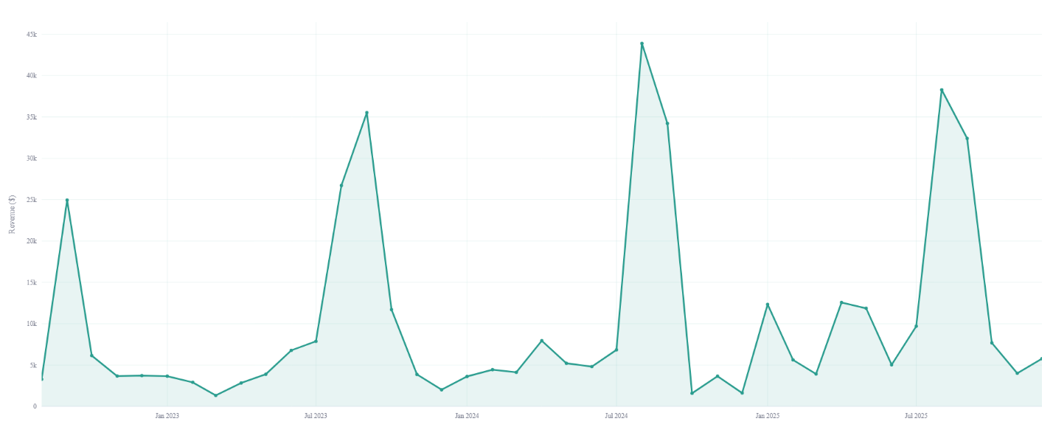

Average sales per month:
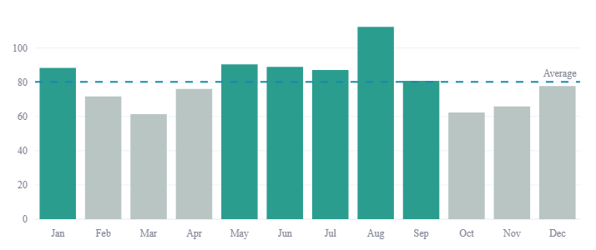
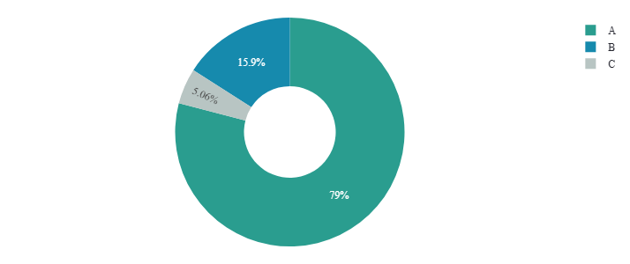

Products’ section:

Revenue per product class


Sales Forecast:


Promotions section:
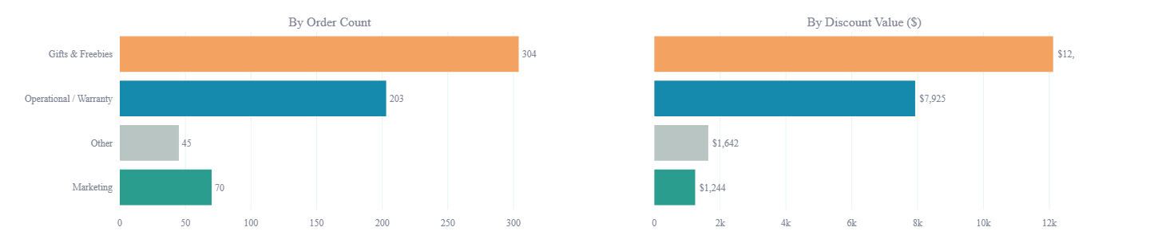
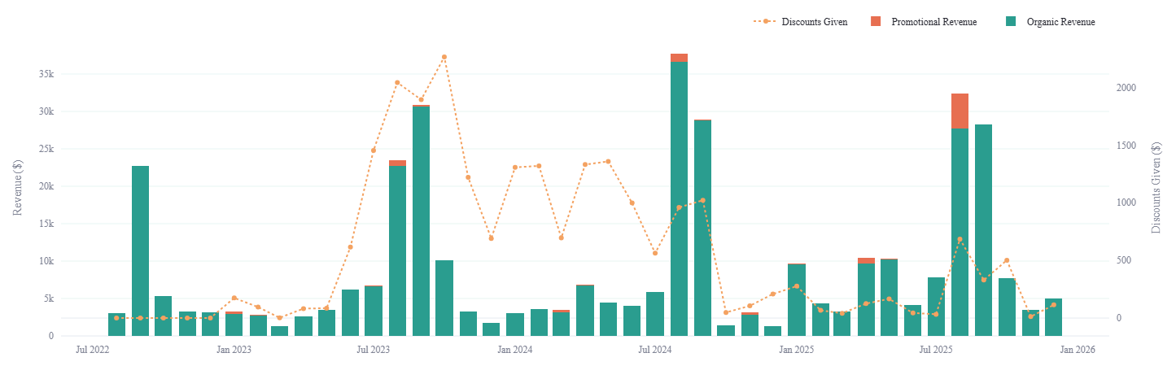
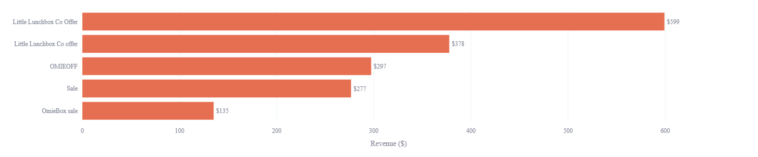
Customers section:
New Customers per Month


Average Order Value: New vs Repeat Customers
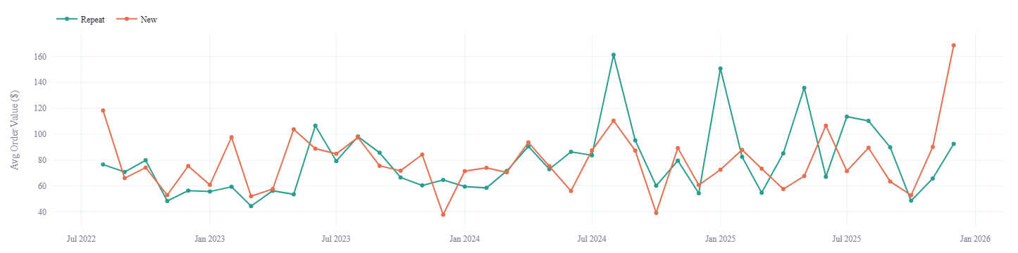
Customers’ Location:
